Classification – Random Forest

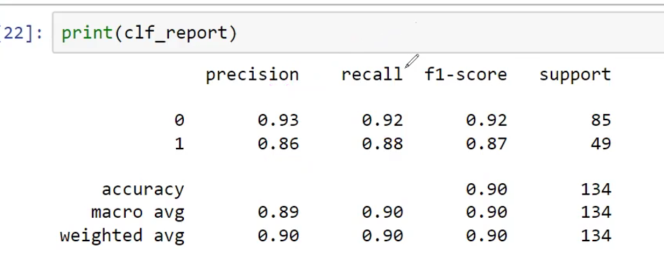

Precision
Non-Purchased (Precision = 93%)
Q: When the model predicts that a customer will NOT purchase, how often is it correct?
A: The model is 93% accurate when identifying non-purchasers.
Purchased (Precision = 86%)
Q: When the model predicts that a customer WILL purchase, how often is it correct?
A: The model is 86% accurate when identifying purchasers.

Recall
Non-Purchased (Recall = 92%)
Q: Of all customers who truly did not purchase, how many did the model successfully identify as non-purchasers?
A: The model correctly identified 92% of actual non-purchasers.
Purchased (Recall = 88%)
Q: Of all customers who truly made a purchase, how many did the model successfully identify as purchasers?
A: The model correctly identified 88% of actual purchasers.

F1-Score
Non-Purchased (F1 = 92%)
Q: How well does the model perform overall when identifying non-purchasers, considering both correctness and coverage?
A: The model achieves an overall performance score of 92% for non-purchasers.
Purchased (F1 = 87%)
Q: How well does the model perform overall when identifying purchasers, considering both correctness and coverage?
A: The model achieves an overall performance score of 87% for purchasers.

Support
Non-Purchased (Support = 85)
Q: How many actual non-purchasers were included in the evaluation?
A: The test dataset contained 85 non-purchasing customers.
Purchased (Support = 49)
Q: How many actual purchasers were included in the evaluation?
A: The test dataset contained 49 purchasing customers.

Accuracy (90%)
Q: Overall, how often is the model correct regardless of category?
A: The model makes the correct prediction 90% of the time, whether the customer is a purchaser or non-purchaser.

Macro Average
Q: What is the model's average performance when giving equal importance to purchasers and non-purchasers?
A: When both customer groups are weighted equally:
- Precision: 89%
- Recall: 90%
- F1-Score: 90%
This shows balanced performance across both classes.

Weighted Average
Q: What is the model's overall performance after considering the actual distribution of purchasers and non-purchasers in the data?
A: After accounting for the number of customers in each group:
- Precision: 90%
- Recall: 90%
- F1-Score: 90%
This reflects the model's practical performance on the dataset.

